Part Number: PT944-48160 (Gas)

PT944-48161 (Hybrid)

Kit Contents
Item # | Quantity Reqd. | Description
1 | 2 | Front Door Sill (L & R)
2
3
Hardware Bag Contents
Item # | Quantity Reqd. | Description
1
2
3
Additional Items Required For Installation
Item # | Quantity Reqd. | Description
1
2
3
Conflicts
None
Recommended Tools
Personal & Vehicle Protection | Notes
Safety Glasses
Safety Gloves
Vehicle Protection | Blankets, Part Boxes
Special Tools | Notes
Installation Tools | Notes
Socket & Ratchet or Wrench | 8mm & 10mm
Torque Wrench
Special Chemicals | Notes
Cleaner | VDC Approved
General Applicability
Gas and Hybrid Models
Recommended Sequence of Application
Item # | Accessory
1
2
3
*Mandatory
Vehicle Service Parts (may be required for reassembly)
Item # | Quantity Reqd. | Description
1
2
3
Legend
STOP: Damage to the vehicle may occur. Do not proceed until process has been complied with.
OPERATOR SAFETY: Use caution to avoid risk of injury.
CAUTION: A process that must be carefully observed in order to reduce the risk of damage to the accessory/vehicle and to ensure a quality installation.
TOOLS & EQUIPMENT: Used in Figures calls out the specific tools and equipment recommended for this process.
REVISION MARK: This mark highlights a change in installation with respect to previous issue.
SAFETY TORQUE: This mark indicates that torque is related to safety.

Care must be taken when installing this accessory to ensure damage does not occur to the vehicle. The installation of this accessory should follow approved guidelines to ensure a quality installation.

These guidelines can be found in the "Accessory Installation Practices" document.

This document covers such items as:-
- Vehicle Protection (use of covers and blankets, cleaning chemicals, etc.).
- Safety (eye protection, rechecking torque procedure, etc.).
- Vehicle Disassembly/Reassembly (panel removal, part storage, etc.).
- Electrical Component Disassembly/Reassembly (battery disconnection, connector removal, etc.).

Please see your Lexus dealer for a copy of this document.

Disassemble the Vehicle.
  - Set the parking brake.
  - Protect the fender.
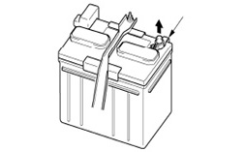
  - Remove the negative battery cable (Fig. 1-1).
Fig. 1-1
10mm socket & ratchet or 10mm wrench
Negative battery cable
CAUTION: Do not touch the positive terminal with any tool while removing the cable.

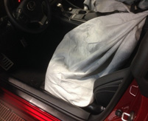
  - Cover the seat with a blanket (Fig. 1-2).
Fig. 1-2

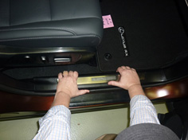
  - Lift the door sill trim piece to disengage the four (4) clips and remove it (Fig. 1-3).
Fig. 1-3
  - Repeat for the other side.

Install the Illuminated Door Sills.
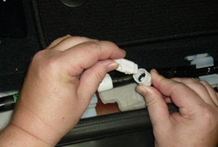
  - Locate the passenger side (RH) prewire connector attached to the floor harness and remove the connector plug (Fig. 2-1).
Fig. 2-1

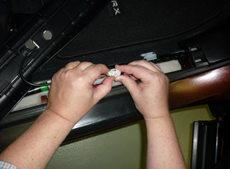
  - Connect the door sill harness to the prewire connector (Fig. 2-2). Ensure the connector engages fully.
Fig. 2-2

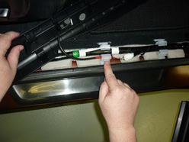
  - Run the door sill harness through the floor harness retention clip (Fig. 2-3).
Fig. 2-3
NOTE: The driver side harness may be too short to route through the clip. In that case, route it next to the OE harness.

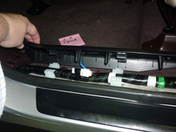
  - Repeat Steps (a) through (c) on the driver side (Fig. 2-4).
Fig. 2-4

Perform a Functional Test.
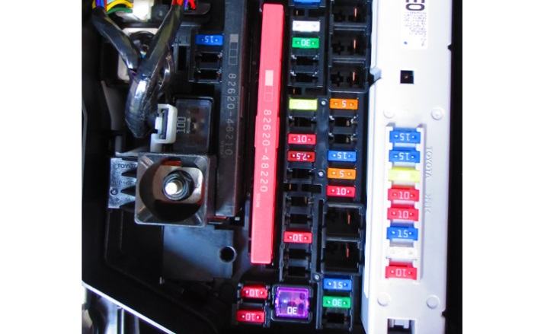
  - Temporarily reconnect the battery negative cable and install the DCC cut fuse (Fig. 3-1).
Fig. 3-1
NOTE: Ensure all doors and the hatch are fully closed before proceeding with the test.

  - Confirm that the Illuminated Door Sills function properly.
    - Door Open: Front door sills are illuminated (Fig. 3-2).
Fig. 3-2
    - Press the door switch: Front door sill illumination dims out after 15 seconds.
NOTE: For gas vehicles the illumination should be white, for hybrid vehicles the illumination should be blue.
  - Disconnect the battery negative cable and remove the DCC cut fuse.
NOTE: Ensure the dome light switch is in the ON position.

Reassemble the Vehicle.
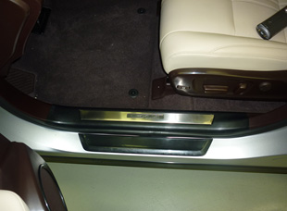
  - Install the illuminated door sills. Ensure all hooks are snapped in (Fig. 4-1).
Fig. 4-1
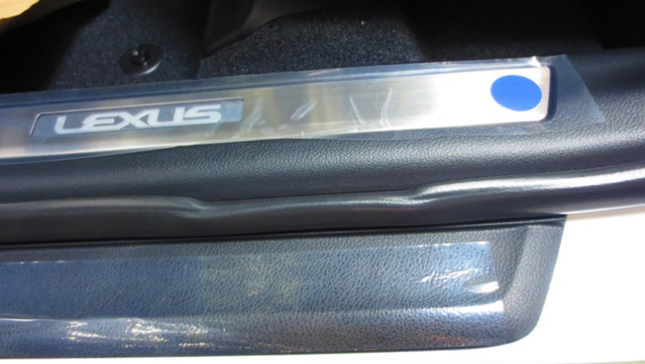
CAUTION: Ensure no wires or the seal are pinched between the sill and the body (Fig. 4-2).
Fig. 4-2
Do not pinch the seal

  - Reconnect the battery.
    - Position the negative battery cable in the original factory position (Fig. 4-3).
Fig. 4-3
10mm socket & torque wrench
Negative battery cable
CAUTION: Do not touch the positive terminal with any tool during installation.
    - Tighten the nut to 48 in-lbf (5.4 N-m).
Torque: 48 in·lbf (5.4 N·m)
  - Perform the final accessory function and vehicle function checks on the next page.
  - Clean up and remove any trash.

Accessory Function Checks
Door open/dome light on
Door closed/dome light off

Vehicle Function Checks
Dome light
Foot well lighting

Front door sills are illuminated (white for gas, blue for hybrid)
Front door sills are not illuminated

Dome light operates properly
Foot well lighting operates normally

Vehicle Appearance Check
Verify the fit of the Illuminated Door Sill Plates
After accessory installation and removal of protective cover(s), perform a visual inspection.

No pinch of weatherstrip

Ensure no damage (including scuffs and scratches) was caused during the installation process.
(For PPO installations, refer to TMS Accessory Quality Shipping Standard.)

